Video Sessions 1 and 2 (Speaker: Mr. Dennis Dupps, CEEMS Technology Resource Specialist, UC; July 15, 2015, 9:00 am–10:30 am; and July 21, 2015, 9:00 am–11:30 am)
Dennis Dupps currently serves as the Technology Resource person for the CEEMS grant at UC. He conducted both the sessions. His biography has been presented on page I-71 as part of the PD session for CEEMS Poster Guidelines and Pointer.
Mr. Dupps needed two jam-packed sessions to share his considerable knowledge of video creation with teachers. Many presenters use slides or even video clips in the delivery of content, but Dennis Dupps added great value by taking the time to include screenshots with deliberate additions of circles and arrows to point the way through a process. When Mr. Dupps asked teachers to raise their hands if they had previously created videos, only a couple hands went up. Since teachers had laptops with internet access, they could follow Mr. Dupps step-by-step guidance in video creation. First and foremost teachers needed to create and maintain a computer folder exclusively for all video related files. Then he instructed teachers to add transitions between slides in previously created PowerPoint presentations.
To assuage any anxiety before teachers took the step of transferring their prepared PowerPoint files into MS Moviemaker, Lakisha Edmondson shared her experience. As a CEEMS cohort three participant, Ms. Edmondson created her first video during the 2014 Summer Institute for Teachers. She assured the audience that they could not only create videos but do so such that they turned out as creative, appealing endeavors. The audience then viewed evidence of Ms. Edmonson’s creative accomplishments by watching her video.
Mr. Dupps then introduced teachers to acceptable background music options, He demonstrated how to split audio files into separate music and voice-over files. That way teachers can reduce the volume on the music so that it stays in the background and does not overwhelm the spoken words. Mr. Dupps cautioned his students against reading text already on the screen. Instead they should add value by providing context for screen content or highlighting the most important point.
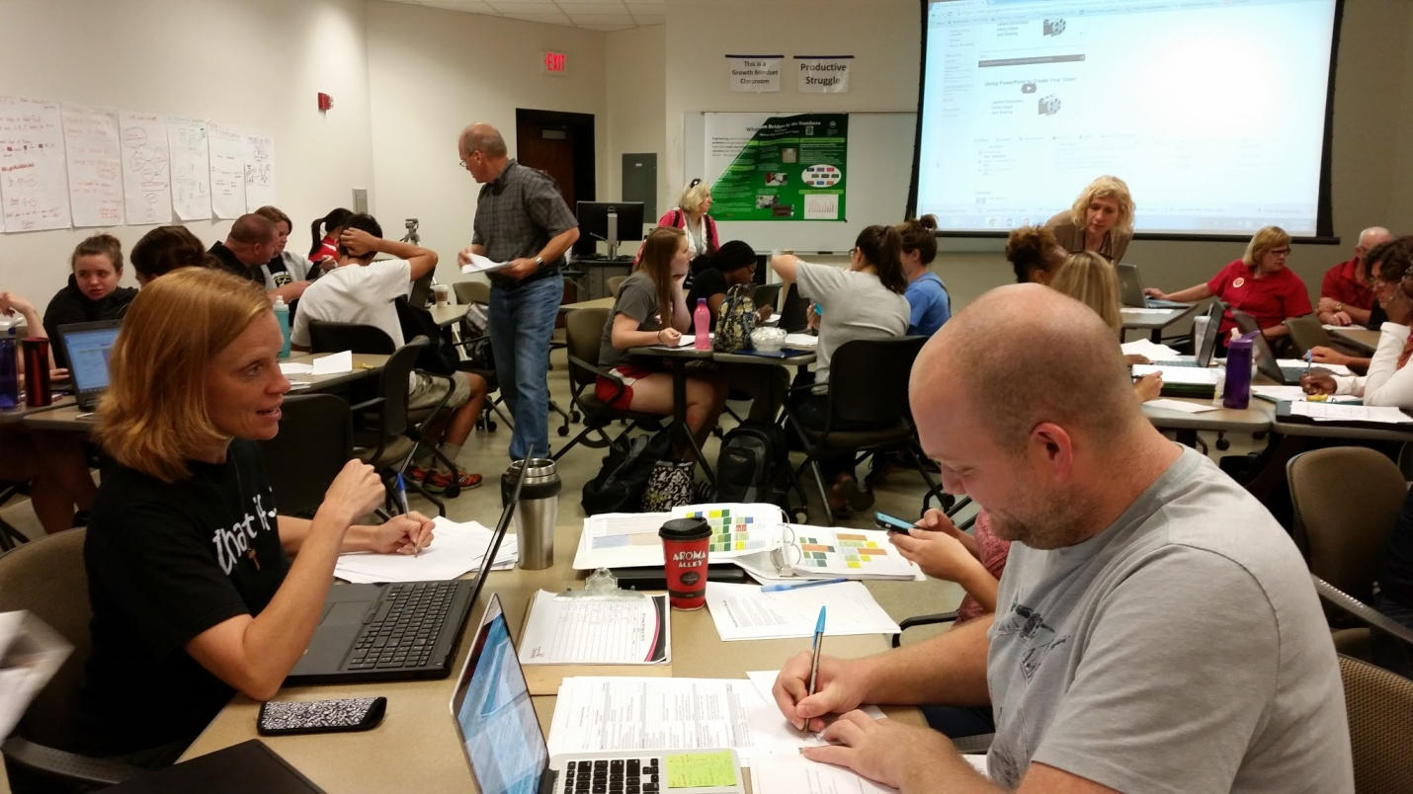
Figure 1: CEEMS and RET Teachers Actively Engaged In Learning New Technology Tools
Although Mr. Dupps detailed a clear path to video creation from start to finish, he made clear that teachers could consider other options according to their confidence and creativity. During the second session in particular he shared more resources for obtaining music as well as recording and manipulating sound files. Despite the popular moniker of video, students learned that their creations should appeal to the sense of sound in addition to sight.
Understanding that the task of comprehending and then applying the expertise he acquired over time might take the audience more than a few hours of class time, Mr. Dupps offered them the option of one-on one consultation either in person or virtually. By the end of the second session many teachers, had already made significant progress toward their goal of creating an attractive video, visually and aurally.

